
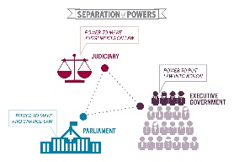
Separation of Powers
The information on the back of the page is jumbled up in the wrong order! You need to match the correct role and composition with the correct power and write it in the table below.
POWER | ROLE | COMPOSITION (How the power is made up)
Parliament | The role of the Parliament is… | Parliament (also referred to as the Legislature) is made up of…
Executive | The role of the Executive is… | The Executive is made up of…
Judiciary | The role of the Judiciary is… | The Judiciary is made up of…
The role of the Judiciary is to make judgements about the law.
  The role of the Executive is to put law into action.
Parliament (also referred to as the Legislature) is made up of the Queen (represented by the Governor-General), the Senate and the House of Representatives. | The role of the Parliament is to make and amend the law.
The Executive is made up of the Queen (represented by the Governor-General), Prime Minister and ministers.
  The Judiciary is made up of the High Court and other federal courts.

